COMMANDER HAJI AINOLNIZAM BIN HAJI IBRAHIM, Royal Brunei Navy
Director of the RBAF Religious Directorate
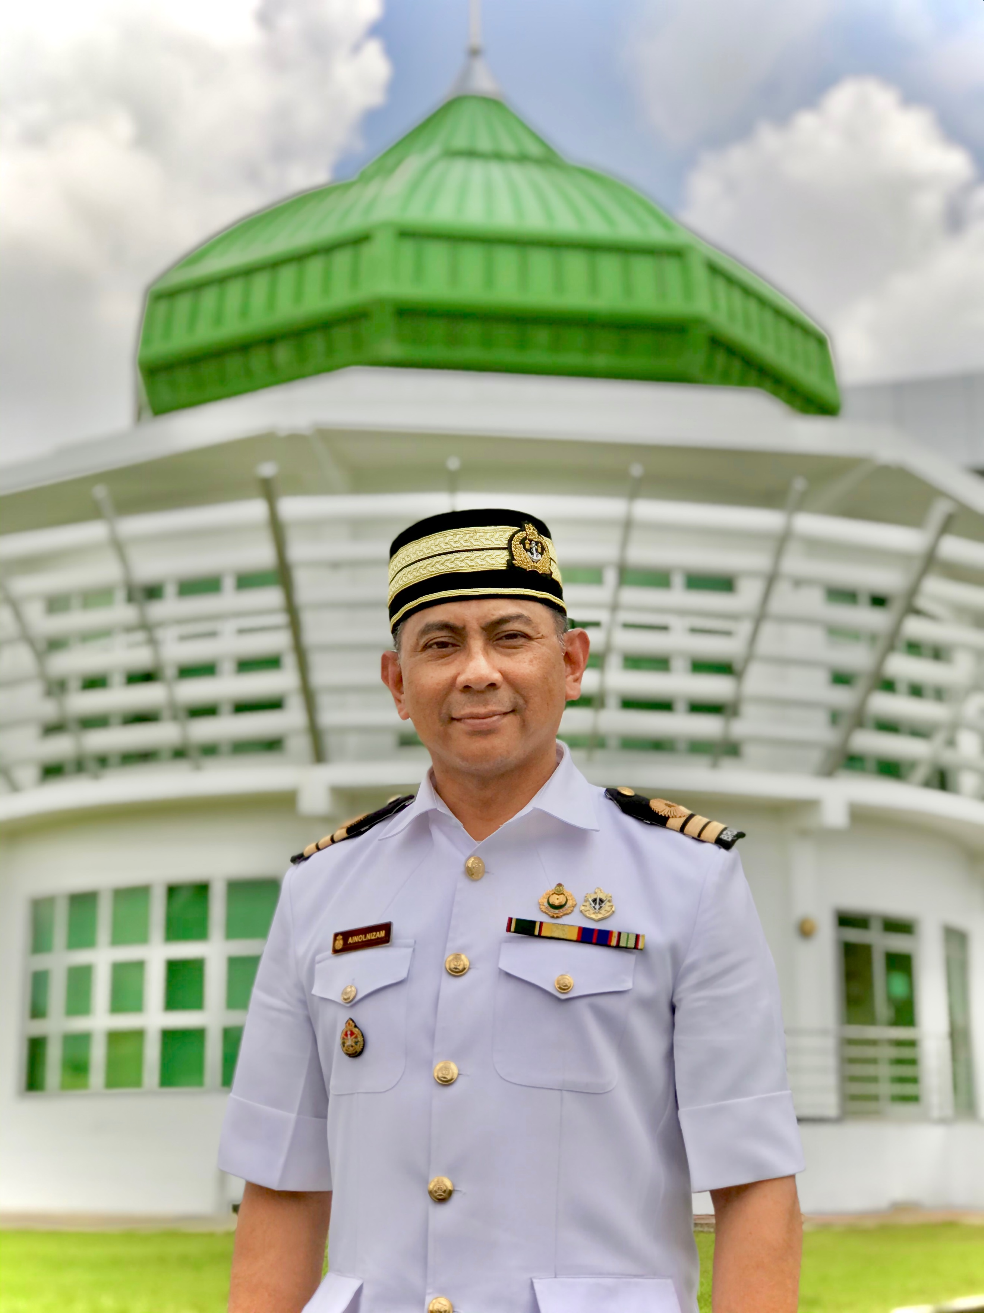

Cdr Haji Ainolnizam Hj Ibrahim is the Acting Director of the Royal Brunei Armed Forces Religious Directorate (JAMA’AT) since its upgrade from unit level to directorate level in May 2021. He has been holding the post since 22 July 2016.
Significant projects that have been manifested during his time in JAMA’AT are as follow:
- Religious Research and Educational signing record with religious academia Seri Begawan Religious Teachers University College
- RBAF own printed Mushaf al-Quran
- Street Dakwah (Rehlah Dakwah) within RBAF and with Bruneian community
- The upgrading of Religious Department to directorate level.
Cdr Hj Ainolnizam was born in Belait District, Brunei Darussalam on 26 May 1973. He was in the twinning programme between University Brunei Darussalam and the University of Glasgow and graduated from the University of Glasgow in Scotland with a Bachelor of Engineering Electronics and Electrical Engineering in 15 July 1999. While studying in Brunei Darussalam, he was a part time Disc Jockey at the Brunei national radio and also a part time actor for the Brunei national television programme. On 24 January 2000, he was successfully selected to become a RBAF Potential Officers with among 5 others and underwent his Recruit Training in RBAF Training Center.
Cdr Hj Ainolnizam went to Britannia Royal Naval College (BRNC) in HMS Dartmouth for his Officer Cadet Training in January 2001 and graduated from that college on the 3 August 2001. He was then promoted to the rank of Lieutenant on the similar month in the Royal Brunei Navy (RBN). He was appointed as Officer Under Training onboard KDB WASPADA and also tasked to under-study the responsibility and duty of the Naval Engineering Officer.
On June 2002 until December 2002, Cdr Ainolnizam went to HMS COLLINGWOOD in the United Kingdom to attend the System Engineering Management Course as to qualify himself as the Weapon Engineering Officer. He was then selected to be part of the Project Officers as an overseer for the RBN’s ship building at BAE System in Scotland in the year 2003 until 2006.
Cdr Ainolnizam hold multiple posts back in the Royal Brunei Navy such as Fleet Engineering Officer, Officer in Command at the Integrated Weapon Complex, RBN Staff Officer 2 Inspectorate and the Training Officer at the Naval Training School.
He was appointed as the ADC to the Crown Prince in the year 2011 to 2013 before undergoing his Command and Staff Course in the Sultanate of Oman for almost a year in August 2013.
On December 2014, Cdr Ainolnizam was given a responsibility to head the KDB DARUSSALAM repair project in Labuan at which he successfully handed the ship back to the RBN in December 2015.
He is married to Pengiran Nur Lainul Qalbi and blessed with five boys.

761 MAJOR ARIFFIN BIN AMIT
Staff Officer Grade One in Training
RBAF Religious Directorate
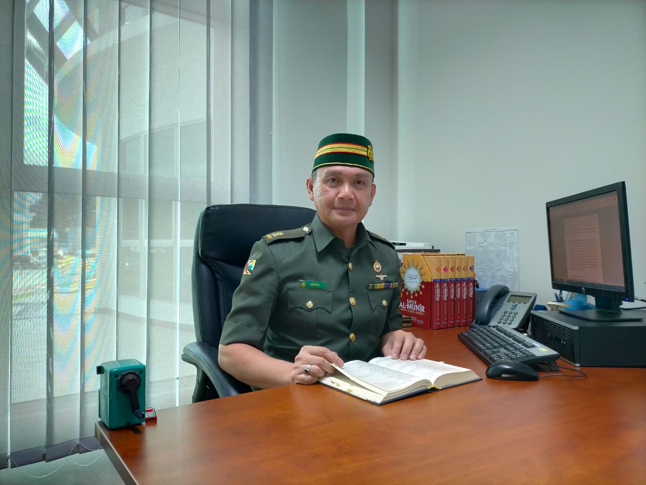

Major Ariffin bin Amit started his career as civilian Religious Officer in Ministry of Defence for three years since 2003. He was then commissioned as a Military Religious Officer in 2006 and has been working with RBAF Religious Directorate (JAMA’AT) for 16 years. He is now appointed as Staff Officer Grade One in Religious Training (Training) looking over the RBAF religious education and training as well as Religious counselling service in the RBAF. He graduated from University Brunei Darussalam in BA Islamic Study and completed his Command Staff Course, from the Sultan’s Armed Forces, Sultanate of Oman in 2020.

Major Ariffin has made a lot of contribution in enhancing the importance of religious values in RBAF such as rehabilitation program for the drug addicts by instilling religious values and education as part of the program (Syifaul Insan Program), he joined maritime deployment to Germany, China and Vietnam as Imam and promoted religious studies on board, became the religious instructor for survival and jungle warfare training and many more. He is also one of the certified religious preachers (daie) in Royal Brunei Armed Forces and is known as a well-known preacher for religious program in the armed forces and Brunei Darussalam.

Major Ariffin is married to Norliliwati binti Momin and blessed with nine children.

863 MAJOR ABDUL MUJIB BIN HAJI JAPAR
Religious Officer (Attachment)
RBAF Religious Department
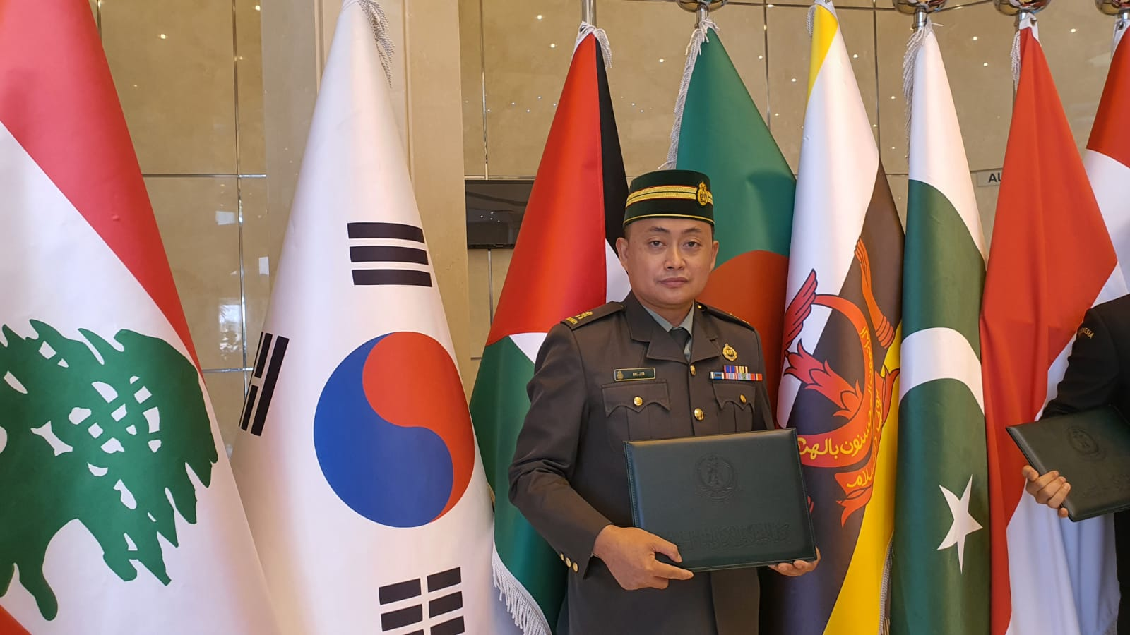

Major Abdul Mujib bin Haji Japar was commissioned as a Military Officer in 2008 upon completion of his Officer Cadet School in Sandhurst Academy, United Kingdom. He graduated in BA Usuluddin (Dakwah and Islamic Culture) from University of Al-Azhar, Egypt in 2004. In 2021, he completed two postgraduate programs which are Master of Science in Military Science from National Defence University, Kingdom of Saudi Arabia and Master of Government (Islamic Governance) from University of Brunei Darussalam.

Major Abdul Mujib’s professional background has come from vast experiences as he worked with several ministries prior to joining the armed forces. He worked with the Ministry of Religious Affairs in 2006 and worked as Arabic Linguist Teacher at Hassanal Bolkiah Arabic Secondary School. He had also worked at the Ministry of Foreign Affairs and Trade as Research Officer in the Department of International Organisation for two years. With these experiences and his deep knowledge in religious and Arabic linguistic, he has excelled in the workforce and held an appointment as Assistant Head of Religious Department RBAF for almost a year in 2019-2020.

He has also held few military appointments and joined United Nation Interim Force in Lebanon for peacekeeping mission in Lebanon in 2013. He is one of the qualified United Nation peacekeeping instructor in RBAF after joining the United Nations Military Expert on Mission Course at the Malaysian Peace Keeping Centre in 2018. He is a certified religious preacher (daie) and become a well-known preacher in RBAF.

Captain Noria Fatriah binti Haji Abd. Mutalif started her career at the RBAF Religious Directorate (JAMA’AT) in 2014 and has been working as Religious Officer for almost nine years. Since then, she has been working extensively in religious education and training as well as at the Islamic Family Development and Guidance cell. As JAMA’AT has been upgraded to a directorate level in 2021, Captain Noria has also been working on the doctrine of Ahli Sunnah Wal-Jamaah looking into religious doctrine and current ideologies.

Education Background:

Graduated in BA Usuluddin (Aqidah and Philosophy) from Al-Azhar University, Egypt in 2011 and in 2013 graduated from Monash University, Australia in Master of Islamic Studies.

